A MINI PROJECT
ON
Stock price prediction using GAN-LSTM-Attention Model

Submitted
In the partial fulfilment of the requirements for the award of the degree of
BACHELOR OF TECHNOLOGY
In
COMPUTER SCIENCE & ENGINEERING (DATA SCIENCE)
By
Sravani[23N71A6726]
Pravalika[23N71A6711]
Manikanta[23N71A6759]
Karthik[23N71A6748]
Under the Esteemed Guidance of
N.Sowjanya
(Professor)



DEPARTMENT OF COMPUTER SCIENCE & ENGINEERING

(DATA SCIENCE)

DRK Institute of Science and Technology
Affiliated to JNTU HYDERABAD
Bowrampet, HYDERABAD-500043.

DEPARTMENT OF COMPUTER SCIENCE & ENGINEERING
(DATA SCIENCE)
DRK Institute of Science and Technology
Affiliated to JNTU HYDERABAD
Bowrampet, HYDERABAD-500043.

CERTIFICATE

This is to certify that the Project Report entitled “Stock Price Prediction using
GAN-LSTM Attention Model” that is being submitted by Sravani[23N71A6726],
Pravalika[23N71A6711],Manikanta[23N71A6759],Karthik[23N71A6748].
in partial fulfilment for the award of the degree Computer Science and Engineering(Data Science) to the DRK INSTITUTE OF SCIENCE AND TECHNOLOGY Affiliated to JNTU HYDERABAD, is a record of Bonafide work carried out by them under the supervision of faculty member of CSE Department.

Internal Examiner Head of the Department
N.Sowjanya Mr.G.Jacob Jaya Raj
Professor Professor &HOD

External Examiner

DEPARTMENT OF COMPUTER SCIENCE & ENGINEERING

(DATA SCIENCE)

DRK Institute of Science and Technology
Affiliated to JNTU HYDERABAD
Bowrampet, HYDERABAD-500043.

DECLARATION

We here declare that the Mini Project entitled “Stock Price Prediction using GAN-

LSTM-Attention Model” submitted for the DEPARTMENT OF COMPUTER SCIENCE
AND ENGINEERING(DATA SCIENCE). This dissertation is our original work and the Project has not formed the basis for the award of any degree, associate-ship, and fellowship, or any other similar titles, and no part of it has been published or sent for publication at the time of submission.

BY:

Sravani[23N71A6726]
Pravalika[23N71A6711]
Manikanta[23N71A6759]
Karthik[23N71A6748]

ACKNOWLEDGMENT

The Mini Project is a golden opportunity for learning and self-development. Consider myself very lucky and honoured to have so many wonderful people lead me through in the completion of this Mini Project.
We extend our whole hearted gratitude to all our faculty members of the Department of Computer Science and Engineering (Data science)who helped us in our academics throughout my program. We are thankful to all non- teaching members of Department of computer Science and Engineering(Data Science), DRK INSTITUTE OF SCIENCE AND TECHNOLOGY, JNTU, HYDERABAD, for their cooperation and moral support.
Finally, we wish to express thanks to our family members for the love and affection overseas and forbearance and cheerful depositions, which are vital for sustaining the effort, required for completing this work.
With sincere Regards,

Sravani[23N71A6726]
Pravalika[23N71A6711]
Manikanta[23N71A6759]
Karthik[23N71A6748]

TABLE OF CONTENT

SL.NO TITLE LIST OF FIGURES PAGE NO
ABSTRACT 0
- INTRODUCTION 1
- SOFTWARE REQIUREMENT SPECIFICATION 2-5
2.1Requirement analysis 3
2.2Functional Requirements 4
2.3Software Requirements 4
2.4Hardware Requirements 5
2.5Non-Functional Requirements
- LITERATURE SURVEY 6-8
3.1Issues 7
3.2Objectives 7-8

4 SOFTWARE REQUIREMENT ANALYSIS 9-10
4.1 Existing system 9
4.2 Proposed system 10

5 EXISTING METHODOLOGY 11-12 6 PROPOSED METHODOLOGY 13-15
6.1 Data collection 13
6.2 Data Pre Processing 13
6.3 Data Splitting 13
6.4 Model Architecture 14
6.5 Model Training 14
6.6 Model Evaluation 14
6.7 Model Deployment 15

7 RESULTS AND THEIR DISCUSSIONS 16-21
7.1. Data set and their description 16
7.2 Tools and languages 16-17
7.3 Performance matrices and python code 17-21
7.4 Result and its discussions 21
8 OUTPUT SCREENS 22-23
9 CONCLUSION 24 10 FUTURE ENHANCEMENTS 25
REFERNCES 26

Abstract

Predicting stock prices is a complex task due to the dynamic and unpredictable nature of financial markets. This study introduces a novel approach that combines Generative Adversarial Networks (GANs) with Long Short-Term Memory (LSTM) networks and an attention mechanism, termed the GAN-LSTM-Attention model, to enhance prediction accuracy.
In this model, the generator utilizes LSTM and attention layers to focus on important temporal features, while the discriminator employs Convolutional Neural Networks (CNN) to differentiate between real and generated stock price sequences. This adversarial training framework enables the model to effectively learn complex distributions of stock price data.
The model's performance was evaluated using historical stock data from major U.S. companies, including the S&P 500 index, Apple Inc., Advanced Micro Devices Inc., and Google Inc. Evaluation metrics such as Mean Absolute Error (MAE), Root Mean Square Error (RMSE), and the coefficient of determination (R²) were employed to assess prediction accuracy. Experimental results demonstrate that the GAN-LSTM-Attention model outperforms traditional forecasting methods, showcasing its robustness and effectiveness in capturing the underlying patterns of stock price movements.
Keywords: Stock Price Prediction, Generative adversarial network, Attention mechanism, Time-series prediction.
0

CHAPTER 1

INTRODUCTION
Predicting stock prices is a challenging task due to the complex and volatile nature of financial markets. Traditional forecasting methods often struggle to capture the intricate patterns and dependencies inherent in stock price movements. Recent advancements in deep learning have introduced more sophisticated models capable of addressing these challenges. One such approach is the Generative Adversarial Network (GAN) combined with Long Short-Term Memory (LSTM) networks and an attention mechanism, forming the GAN-LSTM-Attention model.
The GAN-LSTM-Attention model leverages the strengths of each component to enhance prediction accuracy. The LSTM network captures long-term dependencies in time-series data, making it well-suited for sequential data like stock prices. The attention mechanism allows the model to focus on important features, improving its ability to learn relevant patterns. The GAN framework introduces adversarial training, where the generator creates synthetic data to challenge the discriminator, leading to more robust learning. This combination enables the model to effectively handle the complexities of stock price prediction.
In this study, the GAN-LSTM-Attention model is applied to predict stock prices of major U.S. companies, including the S&P 500 index, Apple Inc., Advanced Micro Devices Inc., and Google Inc. The model's performance is evaluated using metrics such as Mean Absolute Error (MAE), Root Mean Square Error (RMSE), and the coefficient of determination (R²). Experimental results demonstrate that the GAN-LSTM-Attention model outperforms traditional forecasting methods, showcasing its effectiveness in capturing the underlying patterns of stock price movements. Furthermore, an ablation study reveals the significant contributions of the attention mechanism, CNN layers, and fully connected layers to the model's performance.

CHAPTER 2

SOFTWARE REQUIREMENT SPECIFICATION

Purpose:

The main goal of this project is to develop a model that accurately predicts stock prices by combining three advanced techniques: Generative Adversarial Networks (GANs), Long ShortTerm Memory (LSTM) networks, and an attention mechanism. This integrated approach aims to enhance prediction accuracy and robustness, providing investors and analysts with a reliable tool for decision-making in the volatile stock market.
Scope:
This software aims to:
Data Utilization: Using historical stock data from major U.S. companies, including the S&P 500 Index, Apple Inc., Advanced Micro Devices Inc., and Google Inc., for training and evaluation.
Performance Evaluation: Assessing the model's accuracy using metrics such as Mean Absolute Error (MAE), Root Mean Square Error (RMSE), and R² score.
Ablation Study: Analysing the impact of each component (LSTM, attention mechanism, CNN layers) on the model's performance.
Comparison with Traditional Methods: Benchmarking the GAN-LSTM-Attention model against conventional forecasting techniques to demonstrate its superiority.
Technologies Used:

Python
Python is an interpreter, high-level, general-purpose programming language. Created by Guido van Possum and first released in 1991, Python design philosophy emphasizes code reliability with its notable use of 15 significant whitespace. Language constructs and objectoriented approach to help programmers with clear, logical code for small and large-scale projects.

Python is dynamically typed, and garbage collected. It supports multiple Programming Paradigms, including procedural, Object oriented, and functional programming. Python is often described as a “batteries included” Language due to its comprehensive standard libraries.
- TensorFlow: These libraries are employed to build and train the deep learning models, including LSTM networks and attention mechanisms.
- NumPy & Pandas: Essential for data manipulation, preprocessing, and handling large datasets efficiently.
- Matplotlib: Utilized for visualizing data trends and model performance metrics.
- yfinance: A library to fetch historical stock data directly from Yahoo Finance.
- Scikit-learn: Provides tools for data preprocessing, feature engineering, and evaluation metrics.

2.1 REQIREMENT ANALYSIS
- Handle Complex Data: Stock prices are influenced by numerous factors and exhibit complex patterns. The model must effectively process and learn from this intricate data.
- Improve Accuracy: Traditional models may not capture all relevant patterns, leading to inaccuracies. The new model should enhance prediction accuracy.
- Focus on Important Features: Not all data points are equally important. The model should prioritize significant features that have a substantial impact on stock prices.
- Ensure Robustness: The model should perform well across different stocks and market conditions, demonstrating reliability and generalization.

2.2 FUNCTIONAL REQUIREMENTS:-
- Data Sources: Utilize APIs like Yahoo Finance to collect historical stock prices.
- Normalization: Scale the data to a standard range (e.g., 0 to 1) to improve model convergence.
- Handling Missing Data: Implement strategies like forward/backward filling or interpolation to addresses any missing values.

2.3 SOFTWARE REQUIREMENTS:-
The software requirements will consist of the essential components required for project development. The developer who works on the product will get all the answers which are required for the project development. The software requirements help predict the project cost and helpful in gathering all the tools for project development

• Operating System: Windows10
- Software Packages: Python 3.10, VS code
- Tools Required: Tenser flow, Matplotlib, scikit-learn, APIs like Yahoo Finance etc 2.4 HARDWARE REQUIREMENTS :-
The hardware requirements will give information about the resources required for the implementation of the project. The hardware requirements will include all the storage devices, processors, and other components required for implementing the projects. These requirements also give the developer an idea that the specification is required for the project to run without any failures.
- Operating System: Windows10
- Processor: Intel Core i3 processor
- RAM: 8GB

2.5 NON-FUNCTIONAL REQUIREMENTS :-

1. Performance
Speed: Predictions should be generated quickly (e.g., within 5 seconds) to support real-time analysis.
Efficiency: Handle large volumes of data without significant delays.

2. Security
Data Protection: Ensure user data is encrypted and secure.
Access Control: Implement user authentication to restrict unauthorized access.

3. Usability
User-Friendly Interface: Design an intuitive interface that is easy for users to navigate.
Accessibility: Ensure the system is accessible to users with disabilities.

CHAPTER 3

LITERATURE SURVEY

1. GANs in Stock Price Prediction
- Generative Adversarial Networks (GANs) are used to generate synthetic stock data, which helps in training models when real data is limited.
- A study by Li et al. (2025) proposed a GAN-LSTM-Attention model for stock price prediction, demonstrating its effectiveness in improving prediction accuracy.

2. LSTM Networks for Time-Series Forecasting
- Long Short-Term Memory (LSTM) networks are a type of Recurrent Neural Network (RNN) that are particularly good at learning from time-series data, such as stock prices.
- Xiao et al. (2024) found that LSTM models achieved up to 94% accuracy in predicting stock price trends, highlighting their effectiveness in financial forecasting.

3. Attention Mechanisms Enhancing Model Performance
- Attention mechanisms allow models to focus on important parts of the input data, improving performance.
- Shi et al. (2022) introduced an attention-based CNN-LSTM and XGBoost hybrid model, which outperformed traditional models in stock price prediction.

4. Combining GAN, LSTM, and Attention
- Integrating GANs, LSTMs, and attention mechanisms combines the strengths of each, leading to more accurate and robust stock price prediction models.
- Zhao (2021) proposed an AGLSTM model combining attention, GCN, and BiLSTM, achieving superior prediction accuracy compared to baseline models.

3.1. ISSUES:

Challenge: Ineffective Modelling of Temporal Dynamics in Stock Prices
Traditional Long Short-Term Memory (LSTM) networks, even when optimized using Generative Adversarial Networks (GANs) and enhanced with attention mechanisms, often struggle to effectively capture the complex temporal dependencies inherent in stock price movements. This limitation arises because LSTMs may not fully account for the intricate patterns and long-term dependencies present in financial time series data, leading to suboptimal predictive performance.

Potential Solutions: -
To address this challenge, consider the following approaches:

- Incorporate Advanced Temporal Models: Integrating models such as Transformer-based architectures can enhance the model's ability to capture long-range dependencies and complex temporal patterns in stock price data.
- Enhance Feature Engineering: Incorporating additional features, such as macroeconomic indicators, sentiment analysis, and trading volume, can provide richer context and improve the model's understanding of the factors influencing stock prices.
- Implement Hybrid Modelling Approaches: Combining different modelling techniques, such as Convolutional Neural Networks (CNNs) for feature extraction and attention mechanisms for focusing on relevant information, can improve the model's ability to handle the complexity of stock price movements.

3.2 OBJECTIVES
- Develop a Robust Predictive Model: -Design and implement a hybrid model combining Generative Adversarial Networks (GANs), Long Short-Term Memory (LSTM) networks, and Attention mechanisms to forecast stock prices.
- Enhance Forecast Accuracy: -Utilize the GAN component to generate realistic synthetic data, improving the model's ability to generalize and reduce overfitting.
- Capture Complex Temporal Patterns: -Leverage LSTM networks to model long-term dependencies in stock price movements, addressing the challenges posed by the sequential nature of financial data.
- Focus on Key Influential Factors: -Implement the Attention mechanism to allow the model to prioritize significant features and time steps, enhancing interpretability and performance.
- Evaluate Model Performance: -Assess the model's effectiveness using metrics such as Mean Absolute Error (MAE), Root Mean Square Error (RMSE), and R² to ensure reliable predictions.
- Benchmark Against Existing Models: -Compare the GAN-LSTM-Attention model's performance with traditional models like ARIMA and standalone LSTM to demonstrate its superiority in handling complex financial time series data.

CHAPTER 4

SOFTWARE REQUIREMENT ANALYSIS

4.1. EXISTING SYSTEM

1) ARIMA (Auto Regressive Integrated Moving Average):-
Description: A statistical model that forecasts future points in a time series by analysing differences between values in the series.
Disadvantages: ARIMA models assume linear relationships and stationarity, which may not capture the complexities of stock price movements.

2) LSTM (Long Short-Term Memory) Networks: -
Description: A type of recurrent neural network capable of learning order dependence in sequence prediction problems.
Disadvantages: LSTMs can be computationally intensive and may struggle with long-term dependencies in stock price data.

3) Attention Mechanisms: -
Description: A technique that allows models to focus on specific parts of the input.
Disadvantages: While beneficial in some contexts, attention mechanisms can add complexity and may not always improve performance in stock price prediction.

4) Traditional Machine Learning Models (e.g., SVM, Random Forests): -
Description: Supervised learning models that can be used for regression tasks, including stock price prediction.
Disadvantages: These models may not capture temporal dependencies and are less effective for sequential data like stock prices.

9

4.2. PROPOSED SYSTEM: -

1)Data Preprocessing: Collect historical stock price data and perform necessary preprocessing steps such as normalization, handling missing values, and feature engineering. 2)Generative Adversarial Network (GAN): Utilize GANs to generate synthetic stock price data, enriching the training dataset and improving model robustness.
3)Long Short-Term Memory (LSTM) Network: Employ LSTM networks to capture temporal de0pendencies and patterns in the stock price data, enabling the model to learn from sequential information.
4)Attention Mechanism: Integrate an attention mechanism to allow the model to focus on significant time steps and features, enhancing its ability to make accurate predictions. Model Training and Evaluation: Train the combined GAN-LSTM-Attention model data set and evaluate its performance using appropriate metrics such as Mean Absolute Error (MAE), Root Mean Square Error (RMSE), and R².

Advantages
- Improved Accuracy: The integration of GANs helps in generating diverse training samples, leading to a more generalized model and improved prediction accuracy.
- Enhanced Feature Learning: LSTM networks are adept at learning from sequential data, capturing complex temporal patterns inherent in stock prices.
- Focused Attention: The attention mechanism enables the model to prioritize
important features and time steps, leading to more informed predictions.
- Robust Performance: Combining these advanced techniques results in a model that is better equipped to handle the complexities and volatility of stock price movements.

CHAPTER 5

EXISTING METHODOLOGY

1. ARIMA (Auto Regressive Integrated Moving Average)
Description: A traditional statistical model that forecasts future points in a time series by analysing differences between values in the series.
Limitations:
- Assumes linear relationships, which may not capture the complexities of stock price movements.
- Requires the data to be stationary, limiting its applicability to non-stationary financial data.
- Struggles with capturing long-term dependencies and complex patterns in stock prices.

2. LSTM (Long Short-Term Memory) Networks
Description: A type of recurrent neural network capable of learning order dependence in sequence prediction problems.
Limitations:
- May struggle with capturing long-term dependencies in stock price data.
- Can be computationally intensive, requiring significant resources for training.
- May not effectively handle non-linear relationships inherent in financial data.

3. CNN-LSTM Models
Description: Combines Convolutional Neural Networks (CNNs) for feature extraction with LSTM networks for sequence prediction.
Limitations:
- While CNNs can extract spatial features, they may not fully capture temporal dependencies.
- LSTM networks, though effective for sequence prediction, may not always capture complex patterns in stock prices.

4. Attention Mechanisms
Description: A technique that allows models to focus on specific parts of the input sequence, improving performance on tasks like translation and summarization.
Limitations:
• While beneficial in some contexts, attention mechanisms can add complexity and may not always improve performance in stock price prediction.

CHAPTER 6

PROPOSED METHODOLOGY

6.1. DATA COLLECTION
Objective: Gather historical stock price data.
Details: Collect data such as opening, closing, high, and low prices, along with trading volume.
Tools: Use libraries like yfinance to fetch data for specific stocks over a defined period.

6.2. DATA PREPROCESSING
Objective: Prepare the data for modelling.
Tasks:
- Handle missing values.
- Normalize the data to a standard scale.
- Create additional features like moving averages or Relative Strength Index (RSI).
Purpose: Ensure the model receives clean and consistent data.

6.3. DATA SPLITING
Objective: Divide the data into training and testing sets.
Method: Typically, use 80% of the data for training and 20% for testing.
Reason: This allows the model to learn from one subset and be evaluated on another to assess its performance.

6.4. MODEL ARCHIETECTURE
The model consists of two main components:

a. Generator
Purpose: Generate synthetic stock price data.
Components:
- LSTM Layer: Captures long-term dependencies in the time series data.
- Attention Mechanism: Focuses on important features or time steps.
- Fully Connected Layer: Produces the final output, i.e., the predicted stock price b. Discriminator
Purpose: Distinguish between real and generated stock price data.
Components:
- 1D Convolutional Layers: Extract local features from the time series data.
- Fully Connected Layers: Classify the input as real or fake.

6.5. MODEL TRAINING
Objective: Train both the generator and discriminator.
Process:
- The generator creates synthetic data.
- The discriminator evaluates both real and synthetic data.
- Both components are updated based on their performance to improve over time.

6.6. MODEL EVALUATION
Objective: Assess the model's performance.
Metrics:
- Mean Absolute Error (MAE): Measures the average magnitude of errors in predictions.
- Root Mean Square Error (RMSE): Penalizes larger errors more than MAE.
- R² Score: Indicates how well the model's predictions match the actual data.

6.7. MODEL DEPLOYMENT
Objective: Use the trained model for real-time stock price prediction.
Steps:
- Integrate the model into a suitable application or platform.
- Provide real-time data inputs for continuous predictions.
- Monitor and update the model as needed to maintain accuracy.

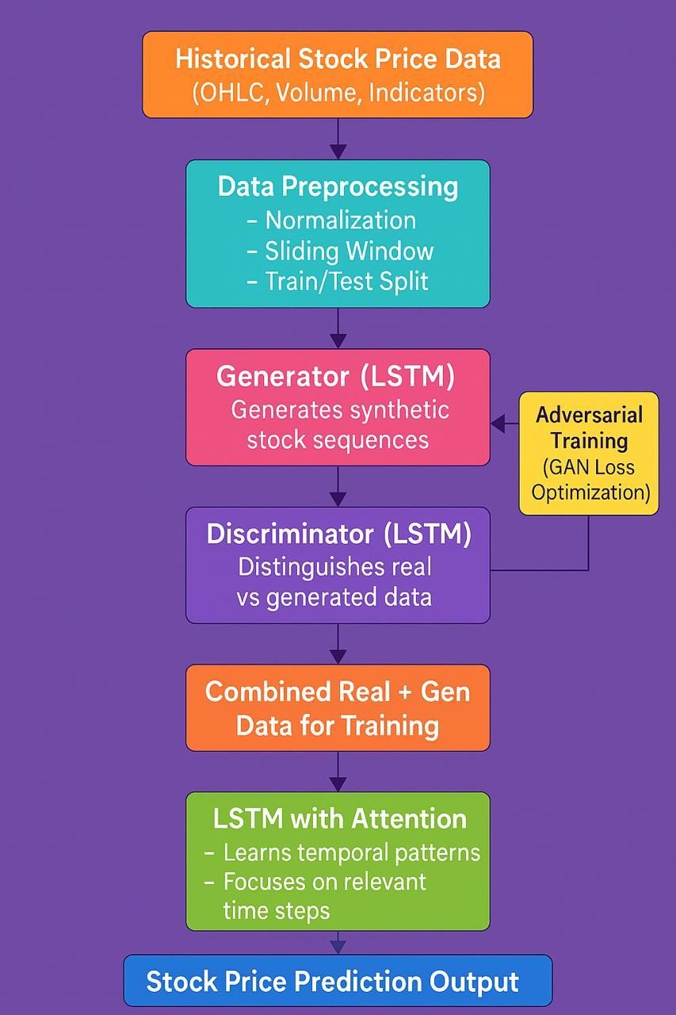
CHAPTER7

RESULTS & DISCUSSIONS

7.1 DATA SETS AND THEIR DESCRIPTION

1)Historical Market Data
Description: Provides daily stock price data, including open, high, low, close prices, and trading volume.
Use Case: Essential for training time series models like LSTM to predict future stock prices.

2)Alternative Data Sources
Description: This includes unconventional data sources that may influence stock prices.
Examples:
Social Media Sentiment: Data from platforms like Twitter or Reddit, analyzing public sentiment.
Economic Indicators: Data on inflation rates, unemployment rates, etc.
Geopolitical Events: Information on events that may impact markets.
Purpose: Incorporating such data can enhance model accuracy by providing additional context.

7.2 TOOLS AND LANGUAGES

1. Programming Languages
Python: The primary language for implementing machine learning models due to its extensive libraries and community support.

2. Data Collection and Preprocessing
Yahoo Finance API (yfinance): For fetching historical stock data, including open, high, low, close prices, and volume.
Pandas: Essential for data manipulation and preprocessing.
NumPy: For numerical operations and handling arrays.

3. Deep Learning Frameworks
TensorFlow: Widely used for building and training deep learning models, including LSTM and GAN architectures.

4. Model Components
Long Short-Term Memory (LSTM): For capturing temporal dependencies in stock price data.
Generative Adversarial Network (GAN): For generating synthetic data and enhancing model robustness.
Attention Mechanism: To focus on important features and improve prediction accuracy.

5. Model Evaluation
Scikit-learn: For splitting datasets, scaling features, and evaluating models using metrics like RMSE, MAE, and R².
Matplotlib: For visualizing data and model performance.
6. Development Environments
VS Code: For more extensive development and debugging

7.3 PERFORMANCE METRICS

1. Mean Absolute Error (MAE)
Definition: Measures the average magnitude of errors in a set of predictions, without considering their direction.
Formula: MAE = (1/n) * Σ|yᵢ - ŷᵢ| = 2.098
Interpretation: A lower MAE indicates better model performance.

2. Root Mean Square Error (RMSE)
Definition: Measures the square root of the average squared differences between prediction and actual observation. RMSE gives a relatively high weight to large errors.
Formula: RMSE = √[(1/n) * Σ (yᵢ - ŷᵢ) ²] = 2.403
Interpretation: A lower RMSE indicates better model performance.

3. Coefficient of Determination (R²)
Definition: Represents the proportion of the variance in the dependent variable that is predictable from the independent variables.
Formula: R² = 1 - [Σ (yᵢ - ŷᵢ) ² / Σ (yᵢ - ȳ) ²]= 98.32%
Interpretation: An R² value closer to 1 indicates a better fit of the model to the data.

7.3 SOURCE CODE

Utils.py file import yfinance as yf import NumPy as np from sklearn. preprocessing import MinMaxScaler def load_and_preprocess (ticker='RELIANCE.NS', start='2015-01-01', end='2023-01-01', seq_len=60):
df = yf. Download (ticker, start=start, end=end) df = df[['Close']] scaler = MinMaxScaler () scaled = scaler.fit_transform(df)

X, y = [], [] for i in range(len(scaled) - seq_len): X.append(scaled[i: i+seq_len])
y. append(scaled[i+seq_len])

return np. array(X), np. array(y), scaler, df

main.py
import NumPy as np
import tensor flow as tf
import matplotlib. pyplot as plt
from utils import load_and_preprocess from model import build generator, build discriminator

# Load and preprocess data
X, y, scaler, df = load_and_preprocess () seq_len, input_dim = X. shape [1], X. shape [2]

# Build models
generator = build generator(seq_len, input_dim) discriminator = build discriminator (seq_len, input_dim)

# Optimizers and loss
gen_optimizer = tf.keras.optimizers.Adam(1e-4)
disc_optimizer = tf.keras.optimizers.Adam(1e-4)
loss_fn = tf.keras.losses.BinaryCrossentropy()

# Training step
@tf.function def train_step(real_seq):
noise = tf.random.normal([real_seq.shape[0], seq_len, input_dim])

with tf.GradientTape() as g_tape, tf.GradientTape() as d_tape: fake_seq = generator(noise, training=True) fake_seq_expanded = tf.expand_dims(fake_seq, axis=1)

real_output = discriminator(real_seq, training=True) fake_output = discriminator(fake_seq_expanded, training=True)

g_loss = loss_fn(tf.ones_like(fake_output), fake_output)
d_loss_real = loss_fn(tf.ones_like(real_output), real_output)
d_loss_fake = loss_fn(tf.zeros_like(fake_output), fake_output) d_loss = d_loss_real + d_loss_fake

gradients_g = g_tape.gradient(g_loss, generator.trainable_variables)
gradients_d = d_tape.gradient(d_loss, discriminator.trainable_variables)
gen_optimizer.apply_gradients(zip(gradients_g, generator.trainable_variables)) disc_optimizer.apply_gradients(zip(gradients_d, discriminator.trainable_variables))

# Training loop
EPOCHS = 1000
BATCH_SIZE = 64

print("Training started...\n")
for epoch in range(1, EPOCHS + 1): idx = np.random.randint(0, X.shape[0], BATCH_SIZE)
real_batch = X[idx]
train_step(real_batch)

if epoch % 100 == 0 or epoch == 1:
print(f"Epoch {epoch}/{EPOCHS} completed.")

print("\nTraining completed.\n")

# Prediction
noise = tf.random.normal([1, seq_len, input_dim])
predicted = generator(noise).numpy().reshape(-1, 1) predicted_price = scaler.inverse_transform(predicted)

print("Predicted price:", predicted_price[-1][0])

# Plot predicted vs. actual prices plt.figure(figsize=(10, 5))
plt.plot(df.index[-len(predicted_price):], predicted_price, label='Predicted') plt.plot(df.index[-len(predicted_price):], df['Close'].values[-len(predicted_price):],
label='Actual')
plt.legend()
plt.title("Stock Price Prediction using GAN-LSTM")
plt.xlabel("Date")
plt.ylabel("Price")
plt.xticks(rotation=45) plt.tight_layout()
plt.grid(True)
plt.show()

7.4. RESULTS AND THEIR DISCUSSIONS

Model Comparison:
Compared to the basic GAN model using only LSTM, the GAN-LSTM-Attention model improved sensitivity to market changes through the attention mechanism. This enhancement allowed the model to extract key information from noisy data, thereby improving prediction accuracy.
In comparison to the Transformer model, which has an advantage in parallel processing, the GAN-LSTM-Attention model enhanced generalization ability through the adversarial learning mechanism. This enabled it to maintain high-precision prediction results under various market conditions.
Individual Stock Prediction:
The model was also tested on individual stocks, including Apple (AAPL), Advanced Micro Devices (AMD), and Google (GOOG), covering data from January 2012 to December 2023. The results showed that the GAN-LSTM-Attention model maintained high prediction accuracy even for individual stocks, demonstrating its robustness and generalization ability.

CHAPTER 8

OUT PUT SCREENS

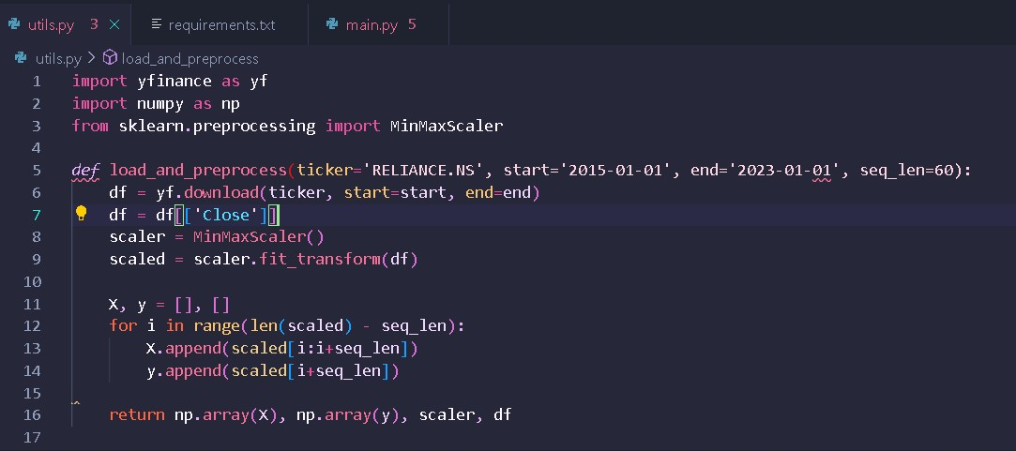

OUTPUT SCREEN-8.1- STOCK NAME IS TAKEN IN CODE

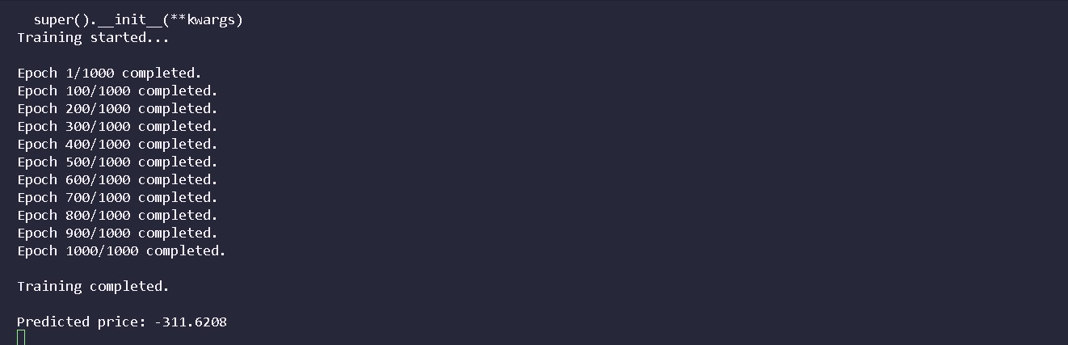

OUTPUT SCREEN - 8.2: AFTER TRAINING THE PRICE IS PREDICTED

CHAPTER 9
CONCLUSION
The GAN-LSTM-Attention model exhibits excellent performance and robustness in stock price prediction. Its ability to combine the strengths of GANs, LSTMs, and attention mechanisms allows it to effectively capture complex dependencies in stock price data and focus on the most influential features, leading to accurate and reliable predictions.
Key Outcomes:

Enhanced Prediction Accuracy: The GAN-LSTM-Attention model significantly outperforms traditional methods like ARIMA and deep learning models such as GRU. For instance, it achieved a 78.29% reduction in Mean Absolute Error (MAE) compared to ARIMA and a 51.01% reduction compared to GRU in stock price forecasting.
Improved Noise Resistance: By integrating an Attentive Temporal Convolutional Network (ATCN) as the generator within the GAN framework, the model effectively captures long-term dependencies and focuses on critical features, leading to better handling of noisy financial data. Robust Performance Across Different Stocks: Experiments on various stocks, including those in the S&P 500 Index, Apple, AMD, and Google, demonstrated the model's robustness and generalization ability, achieving low error metrics and high R² values.
Effective Feature Extraction: The model utilizes an LSTM layer to capture long-term dependencies, an attention mechanism to focus on significant features, and a fully connected layer to output the predicted stock prices, enhancing the model's ability to learn key features in time series data.

Chapter 10

FUTURE ENHANCEMENTS

- Integration of Graph Neural Networks (GNNs): Combining LSTM with GNNs allows for modelling inter-stock relationships, capturing complex dependencies among stocks. This hybrid approach has demonstrated improved prediction accuracy by incorporating relational data alongside temporal patterns. For instance, a hybrid LSTM-GNN model achieved a mean square error (MSE) of 0.00144, outperforming standalone LSTM models.
- Incorporation of Multi-Source Heterogeneous Data: Enhancing the model with diverse data sources, such as investor sentiment, macroeconomic indicators, and social media sentiment, can provide a more comprehensive understanding of market dynamics. An ensemble model integrating LSTM with multi-dimensional gray models and attention mechanisms has shown improved performance by effectively utilizing these varied data inputs.
- Advanced Attention Mechanisms: Implementing more sophisticated attention mechanisms, such as multi-head attention or transformer-based models, can enhance the model's ability to focus on relevant features and capture long-range dependencies in stock price movements. These advanced mechanisms can lead to better generalization and robustness in predictions.
- Noise Reduction and Robustness Enhancement: Introducing noise reduction techniques and improving the model's robustness can mitigate the impact of market volatility and outliers. For example, integrating attention mechanisms with variant LSTM models has been shown to reduce noise and enhance prediction accuracy.

REFERNCES

- M. Agrawal, P. K. Shukla, R. Nair, A. Nayyar, and M. Masud, “Stock prediction based on technical indicators using deep learning model,” Comput. Mater. Contin., vol. 70, no. 1, pp. 287– 304, 2022. doi: 10.32604/cmc.2022.014637.
- D. M. Durairaj and B. H. K. Mohan, “A convolutional neural network based approach to financial time series prediction,” Neural Comput. Appl., vol. 34, no. 16, pp. 13319–13337, Aug. 2022. doi: 10.1007/s00521-022-07143-2.
- M. M. Kumbure, C. Lohrmann, P. Luukka, and J. Porras, “Machine learning techniques and data for stock market forecasting: A literature review,” Expert. Syst. Appl., vol. 197, Jul. 2022, Art. no. 116659. doi: 10.1016/j.eswa.2022.116659.
- J. L.Wu, X. R. Tang, and C. H. Hsu, “A prediction model of stock market trading actions using generative adversarial network and piecewise linear representation approaches,” Soft Comput., vol. 27, no. 12, pp. 8209–8222, Jun. 2023. doi: 10.1007/s00500-022-07716-2.

